Name - Janhvi Saste

PRN - 22311825

Roll No - 282065

Year - SY B

Assignment No - 1

Data Preprocessing for Heart Disease Dataset

Problem Statement :

In the field of medical data analysis, accurately predicting heart disease is critical for early diagnosis and effective treatment. The heart disease dataset contains various patient attributes, such as age, sex, cholesterol levels, and electrocardiogram results, along with a target variable indicating the presence or absence of heart disease. However, raw medical datasets often contain inconsistencies, missing values, and mixed data types, which can hinder the performance of machine learning models. The problem addressed in this assignment is to preprocess the heart disease dataset to make it suitable for downstream machine learning tasks, such as classification, by handling missing values, encoding categorical variables, and standardizing data formats.

Objective :

The primary objective of this assignment is to perform data preprocessing on the heart disease dataset provided in both CSV and Excel formats. Specific goals include:

1. Loading and inspecting the dataset to understand its structure and content.
2. Identifying and analyzing missing values, zero values, and data types.
3. Performing basic data manipulation tasks, such as sorting and summarizing statistics.
4. Converting data types where necessary to ensure compatibility with machine learning algorithms.
5. Preparing the dataset for further analysis or modeling by ensuring it is clean and consistent.

Software Used :

1. Python 3.x
2. Google Colab

Libraries and Packages Used :

The following Python libraries were utilized for data preprocessing and analysis:

* Pandas
* Numpy
* Seaborn
* Matplotlib

Theory :

Methodology :

Data preprocessing is a critical step in the machine learning pipeline, aimed at transforming raw data into a clean, structured format suitable for modeling. The methodology for this assignment includes the following steps :

1. Data Loading: Read the heart disease dataset from CSV and Excel files using Pandas.
2. Data Inspection: Examine the dataset’s shape, missing values, zero values, and unique values to understand its characteristics.
3. Data Cleaning: Handle inconsistencies, such as missing values or incorrect data types, to ensure data quality.
4. Data Transformation: Convert categorical variables and standardize numerical features as needed.
5. Exploratory Analysis: Generate summary statistics and sort data to gain insights into its distribution and relationships.

Main Function :

The primary function of this preprocessing pipeline is to prepare the dataset for machine learning by addressing common data quality issues. Key operations include:

1. read_csv and read_excel: Load data into DataFrames.
2. isnull().sum(): Identify missing values.
3. describe(): Generate summary statistics (mean, standard deviation, etc.).
4. astype(): Convert data types (e.g., changing RestECG to float64).
5. sort_values(): Sort data by specific columns for analysis.

Advantages :

1. Improved Model Performance: Clean and standardized data reduces noise, leading to more accurate machine learning models.
2. Consistency Across Formats: Handling both CSV and Excel formats ensures flexibility in data sources.
3. Insightful Analysis: Exploratory steps like checking unique values and zeros reveal patterns in the data (e.g., prevalence of certain conditions).
4. Scalability: The preprocessing steps can be applied to similar datasets with minimal modifications.

Disadvantages :

1. Time-Consuming: Preprocessing requires careful inspection and multiple steps, which can be labor-intensive for large datasets.
2. Assumption Risks: Imputing missing values or encoding categorical variables may introduce biases if not done thoughtfully.
3. Limited Scope: The current preprocessing does not include advanced steps like feature selection or outlier handling, which may be necessary for optimal modeling.

Applications with Example :

1. Heart Disease Prediction: Preprocessed data can be used to train a logistic regression model to predict whether a patient has heart disease based on features like Age, Chol, and MaxHR.
2. Fraud Detection: Similar preprocessing steps are applied to financial datasets to clean transaction records before detecting fraudulent activities.
3. Customer Segmentation: Retail companies preprocess customer data to cluster users for targeted marketing campaigns.

In this assignment, preprocessing the heart disease dataset enables subsequent tasks, such as building a classifier to predict the AHD (heart disease presence) variable.

Working/Algorithm :

1. Load the dataset using Pandas from CSV and Excel files
2. Compute summary statistics with the describe() function to understand data distribution
3. Visualize data distributions using histograms with Matplotlib and Seaborn to identify patterns
4. Clean the data by handling missing values, converting data types, and addressing zeros
5. Transform the data by sorting, encoding categorical variables, and standardizing numerical features as needed
6. Build a machine learning classification model using Scikit-learn with the prepared data
7. Evaluate model performance using metrics such as accuracy, precision, recall, and F1-score.

Diagram :

Conclusion :

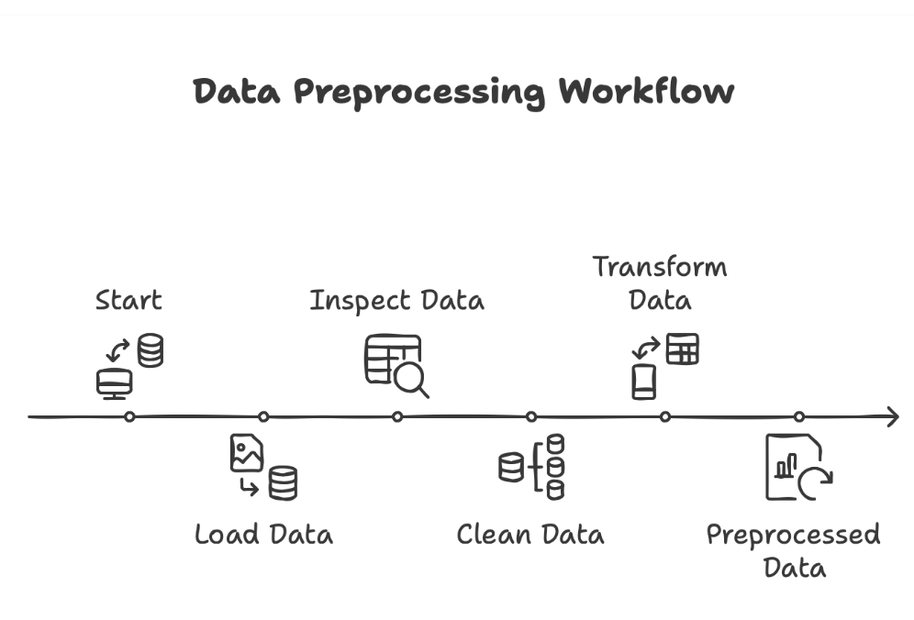The assignment successfully prepared heart disease data for machine learning by loading, inspecting, and performing basic cleaning. Key findings included missing values in Ca and Thal, numerous zeros in binary features like Fbs and ExAng, and the need for consistent data types. While basic preprocessing was achieved, additional steps like imputation, categorical encoding, and feature scaling would further optimize the dataset for modeling. The process emphasized the critical importance of thorough data preparation for sensitive applications like heart disease prediction.